REVA

UNIVERSITY

**Bengaluru, India**

**SCHOOL OF COMPUTER SCIENCE AND INFORMATION TECHNOLOGY**

PROJECT REPORT ON

“E-COMMERCE WEBPAGE”

Submitted in fulfilment of the requirements for the award of the Degree of

BACHELOR OF TECHNOLOGY IN

COMPUTER SCIENCE AND INFORMATION TECHNOLOGY

**Submitted by**

SEJAL SINGH R20EJ042

**DECLARATION**

**I SEJAL SINGH ,** students of B.Tech, School of Computer Science and Information Technology, REVA University, to declare that this project Report entitled **“E-COMMERCE WEBPAGE”** is the result the of project work done by me., School of CIT, REVA University, Bengaluru.

We are submitting this Project Report in partial fulfilment of the requirements of Bachelor of Technology in Computer Science and Information Technology by the REVA University, Bengaluru during the academic year 2022-2023.

**ABSTRACT**

Electronic Commerce is process of doing business through computer networks. A person sitting on his chair in front of a computer can access all the facilities of the Internet to buy or sell the products.

Unlike traditional commerce that is carried out physically with effort of a person to go & get products, ecommerce has made it easier for human to reduce physical work and to save time.    E-Commerce which was started in early 1990’s has taken a great leap in the world of computers, but the fact that has hindered the growth of e-commerce is security. Security is the challenge facing e-commerce today & there is still a lot of advancement made in the field of security.

The main advantage of e-commerce over traditional commerce is the user can browse online shops, compare prices, and order merchandise sitting at home on their PC.

For increasing the use of e-commerce in developing countries the B2B e-commerce is implemented for improving access to global markets for firms in developing countries. For a developing country advancement in the field of e-commerce is essential. The research strategy shows the importance of the e-commerce in developing countries for business applications.

**TABLE OF CONTENTS**

**Table of Contents Pg. No**

**Chapter 1: Introduction**

1.1 Introduction

1.2 What is E-Commerce

1.3 Background of Study

1.4 Objective of project

1.5 Scope of project

**Chapter 2: Project Model View**

2.1 Definition

2.2 Home Page

2.3 Login Page

2.4 Shopping Page

2.5 Order detail Page

2.6 Cart Page

2.7 Checkout Page

2.8 Contact Page

**Chapter 3: Requirements Analysis and Specifications**

3.1 User Action on The Website

3.2 Admin Console

3.3 Inventory and Logistics Management and Order Fulfilment

3.4 User Checkout and Payment

3.5 Promo Code Application

3.6 Mailers

3.7 Reports

**Chapter 4: Conclusion**

4.1 Conclusion

4.2 Future aspect

**Chapter 1**

**1.1 Introduction**

The ‘Online E-commerce Web application’ Services department strives to provide solutions to develop and transfer easy and efficient way in the digital age and to help reduces the human pressure and time. To help support shop collections, the digital initiatives, and external partner institution digital projects, it provides services that include the digitization of analogue objects, metadata management, digital preservation, and discovery and access of digital collections. “Shop Management System” is a web application written for all operating systems, designed to help users maintain and organize shop virtually.

This software is easy to use for both beginners and advanced users. It features a familiar and well thought- out, an attractive user interface, combined with strong searching Insertion and reporting capabilities. The report generation facility of shop system helps to get a good idea of which are the various items brought by the members, makes users possible to get the product easily.

The ‘Online E-commerce Web application’ Services department strives to provide solutions to develop and transfer easy and efficient way in the digital age and to help reduces the human pressure and time. To help support shop collections, the digital initiatives, and external partner institution digital projects, it provides services that include the digitization of analogue objects, metadata management, digital preservation, and discovery and access of digital collections. “Shop Management System” is a web application written for all operating systems, designed to help users maintain and organize shop virtually.

This software is easy to use for both beginners and advanced users. It features a familiar and well thought- out, an attractive user interface, combined with strong searching Insertion and reporting capabilities. The report generation facility of shop system helps to get a good idea of which are the various items brought by the members, makes users possible to get the product easily.

**1.2 What Is E-Commerce?**

E-commerce (electronic commerce) is the buying and selling of goods and services, or the transmitting of funds or data, over an electronic network, primarily the internet. These business transactions occur either as business-to-business, business-to-consumer, consumer-to-consumer, or consumer-to-business.

The terms e-commerce and e-business are often used interchangeably. The term e-tail is also sometimes used in reference to the transactional processes that make up online retail shopping.

In the last two decades, widespread use of e-commerce platforms such as Amazon and eBay have contributed to substantial growth in online retail. In 2011, e-commerce accounted for 5% of total retail sales, according to the U.S. Census Bureau. By 2020, with the start of the COVID-19 pandemic, it had risen to over 16% of retail sales.

**1.3 Background of Project**

E-commerce is fast gaining ground as an accepted and used business paradigm. More and more business houses are implementing web sites providing functionality for performing commercial transactions over the web. It is reasonable to say that the process of shopping on the web is becoming commonplace.

The objective of this project is to develop a general-purpose e-commerce store where any product (such as books, CDs, computers, mobile phones, electronic items, and home appliances) can be bought from the comfort of home through the Internet. However, for implementation purposes, this paper will deal with an online ecommerce store.

An online store is a virtual store on the Internet where customers can browse the catalogue and select products of interest. The selected items may be collected in a shopping cart. At checkout time, the items in the shopping cart will be presented as an order. At that time, more information will be needed to complete the transaction.

Usually, the customer will be asked to fill or select a billing address, a shipping address, a shipping option, and payment information such as a credit card number. An email notification is sent to the customer as soon as the order is placed.

**1.4 Objective of the project**

Project planning is part of project management, which relates to the use of schedules such as Gantt charts to plan and subsequently report progress within the project environment. Initially, the project scope is defined and the appropriate methods for completing the project are determined. Following this step, the durations for the various tasks necessary to complete the work are listed and grouped into a work breakdown structure. The logical dependencies between tasks are defined using an activity network diagram that enables identification of the critical path. Float or slack time in the schedule can be calculated using project management software. Then the necessary resources can be estimated and costs for each activity can be allocated to each resource, giving the total project cost. At this stage, the project plan may be optimized to achieve the appropriate balance between resource usage and project duration to comply with the project objectives. Once established and agreed, the plan becomes what is known as the baseline. Progress will be measured against the baseline throughout the life of the project.

**1.5 Scope of The Project**

The project is about to handle all the information of the shop regarding members. Also, it manages resources which were managed and handled by manpower previously. The main purpose of the project is to integrate distinct sections of the shop into consistent manner so that complex functions can be handled smoothly. The project aims at the following matters

* Automation of product manipulation.
* Buying products.
* To manage information of different types of items.
* Consistently update information of all the item.
* Managing security by providing authorized email & password.
* Manages database efficiently.

**Chapter 2: Problem Model View**

**2.1 Definition**

Electronic commerce or ecommerce is a term for any type of business, or commercial transaction, that involves the transfer of information across the Internet. It covers a range of different types of businesses, from consumer-based retail sites, through auction or music sites, to business exchanges trading goods and services between corporations. It is currently one of the most important aspects of the Internet to emerge.

**2.2 Home Page**

In home page you can view all the products of our website. You can add products that you liked to cart and then you can place order.

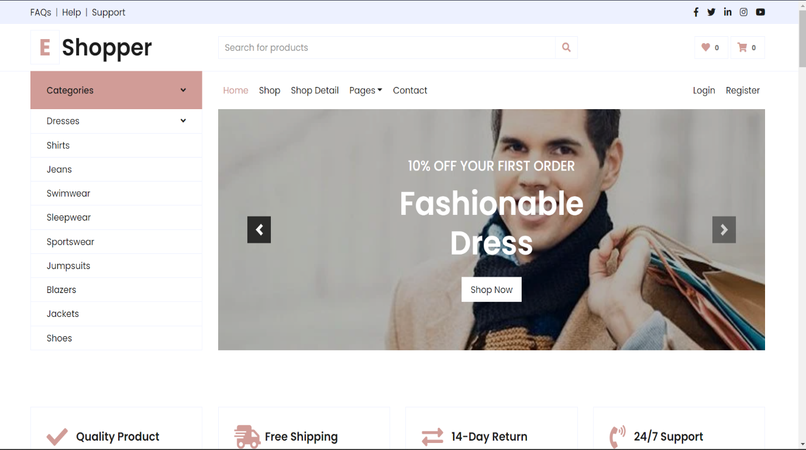

**2.3 Login Page**

Logins are used to gain access to and control of computers, networks, as well as other services and devices.

**2.4 Shopping Page**

In shopping page, you can view products and in additional to that you can also use filters to vies exact products that you need.

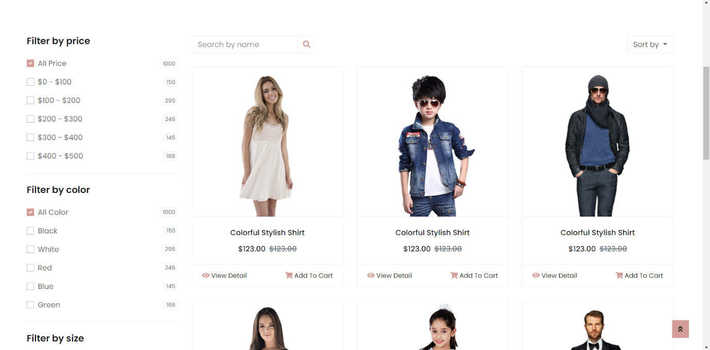

**2.5 order detail Page**

This page will display all your products that you are going to order. And it also displays the product descriptions, customer reviews etc…

**2.7 Cart Page**

This page basically displays all your orders, total pricing, discounts applied to products etc.

**2.8 Checkout Page**

This page displays all your orders to conform before you place your order. And it also collects user address and payment time

**2.9 Contact Page**

This page basically displays the address of our office. And in this page your can also contact our employees for any queries related to your orders.

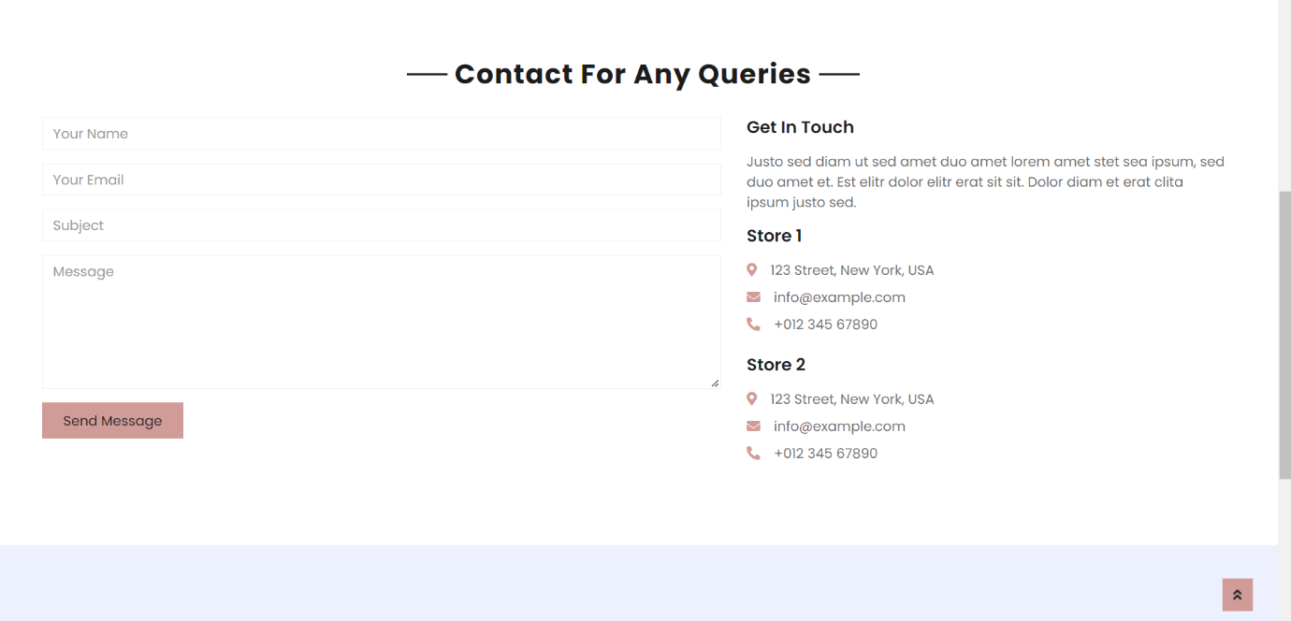

**Chapter 3: Requirements Analysis and Specification**

**3.1 User Action on The Website**

What all actions can a user perform on the website besides making a purchase? These include:

* Searching for products on the home page or throughout the website and on what basis. Products can be searched based on product name, categories, brands etc.
* Sorting products based on the filters provided. Which filters need to be placed? For clothes these can be colours, sizes, and types. For grocery these can be fruits, vegetables, frozen foods, and dairy products. For health insurance products these can be age group, premium limit, waiting period, maternity cover etc.
* Adding products to a wish-list. If these products can indefinitely remain in the wish list till their respective stocks last or can remain for a definite period.
* Making use of available promotional offers and discounts and the business logics behind them.
* Creating an account. Is an account mandatory for making a purchase? Is buying as a guest user an option?

**3.2 Admin Console**

This is an important module of any e-commerce application. A business analyst should clearly determine the aspects that an admin can control from the backend. These include:

* Product Management – All the metadata of the products – Product images, description, seller information, prices etc. Admin should be able to manage this data i.e., add, remove, and edit a product.
* Content management – The design aspect of the website i.e., the static pages a user sees at the front end. It is important to create an attractive and effective website to attract and retain traffic. The answers that a business analyst should seek here are – How will these pages be maintained? Will these pages be uploaded, or a provision has to be made for the admin user such that pages are created through the system?
* Master Management – Besides the product data, there are other masters that need to be managed at the back end. Country, State and city masters, seller masters etc. are just a few examples. For instance pin code masters help in extracting a city when the user enters the pin code while adding the shipping address.
* Admin should be able to carry out promotional activities. Admin user should be able to create promo codes and offers as per the business requirements.

**3.3 Inventory and Logistics Management and Order Fulfilment**

Remember how we add some products to our wish lists and when it is time to buy them, some of the products go out of stock. Or the time when a sale is announced at mid-night, but you log in early morning only to see that the products in sale were brought overnight. We have all been through such times. At the backend, this management is crucial to keep the website up to date with the latest numbers. Whether new products are added, products are returned or exchanged, dispatched, all the logistics and stock details should be maintained in a robust system. Additionally once the products are purchased, some businesses require fulfilment systems that can be used by the dispatch and customer services teams. A business analyst should capture all the business requirements around this piece.

**3.4 User Checkout and Payment**

* Generally, users can check out as registered users or as guest users. An option of creating a new account is also available. Some businesses require customers to make an account to place orders. The information required to create an account needs to be considered.
* Payment options can vary – Cash on Delivery, E-Wallets, 3rd Party Payment Gateways. Vendors are selected as per the requirement of the business.
* The shipping charges and methods. These can be either maintained at the backend or made static.

**3.5 Promo Code Application**

It is important for a business analyst to clarify the application area of these codes. At what point of the user journey can a user apply a promo code?

**3.6 Mailers**

Automated mails are triggered to customers on most actions – when an order is placed, when an order is returned or an exchange request is placed, when complaints are logged, when new accounts are created, etc. Besides the standard practices, promotional campaigns are also run. Requirements should capture the mails to be sent for every action and the content for each mailer.

**3.7 Reports**

Analytics is an integral part of e-commerce in today’s date. A lot of third-party tools are used by businesses to curate reports that’ll help the businesses to make informed decisions and plan further actions. The type of reports should be added to the business requirements.

**Chapter 4: Conclusion**

**4.1 Conclusion**

This project is only a humble venture to satisfy the needs in a shop. Several user-friendly codinghas also adopted. This package shall prove to be a powerful package in satisfying all therequirements of the organization. The objective of software planning is to provide a frameworkthat enables the manger to make reasonable estimates made within a limited time frame at thebeginning of the software project and should be updated regularly as the project progresses.

This website provides a computerized version of shop manipulate system which will benefit the users as well as the visitor of the shop. It makes entire process online where users can search product and buy various product. It also has a facility for common user by login into the system where user can login and can see status of ordered item as well request for items or give some suggestions. It provides the facility of admin’s login where admins can add various item, review users activity and also give occasional discount and also add info about different events for the customer.

**4.2 Future aspect**

The project has a very vast scope in future. The project can be implemented on

intranet in future. Project can be updated in near future as and when requirement

for the same arises, as it is very flexible in terms of expansion. With the

proposed software of database Space Manager ready and fully functional the

client is now able to manage and hence run the entire work in a much better,

accurate and error free manner.

The following are the future scope for the project.

* Should be added payment gateway
* Can be added inventory management system
* Can be added multiple branches
* Can be added multilingual to this site
* And many features can be added this project to make it more robust.